ID | Test Input | Type | Expected Output Must Contain
T1 | (Detailed transcript) 'The user should be able to filter reports by date range, category, and status. Results must load in under 2 seconds. PM: Sarah. Deadline: Q3.' | Detailed | Must extract: filter by date/category/status, 2-second load time, PM Sarah, Q3 deadline. Must NOT add requirements not in transcript.
Result: Pass
The transcripts are Loaded from Google drive correctly with the requirement in Transcript 1 -
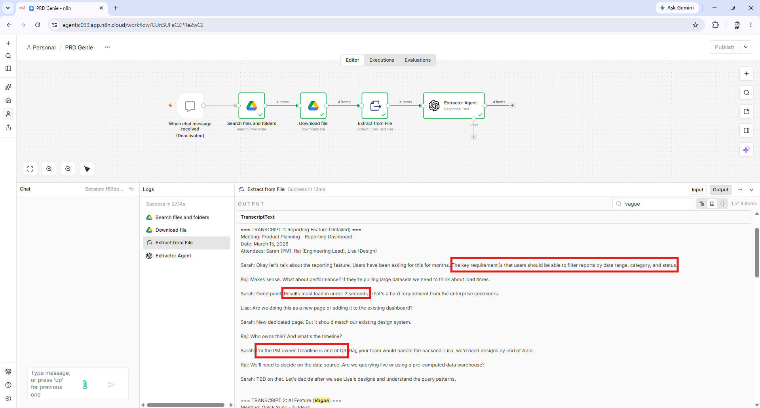

The Extractor Agent with LLM accurately parses transcripts/notes and pulls out requirements, constraints, stakeholders, deadlines;
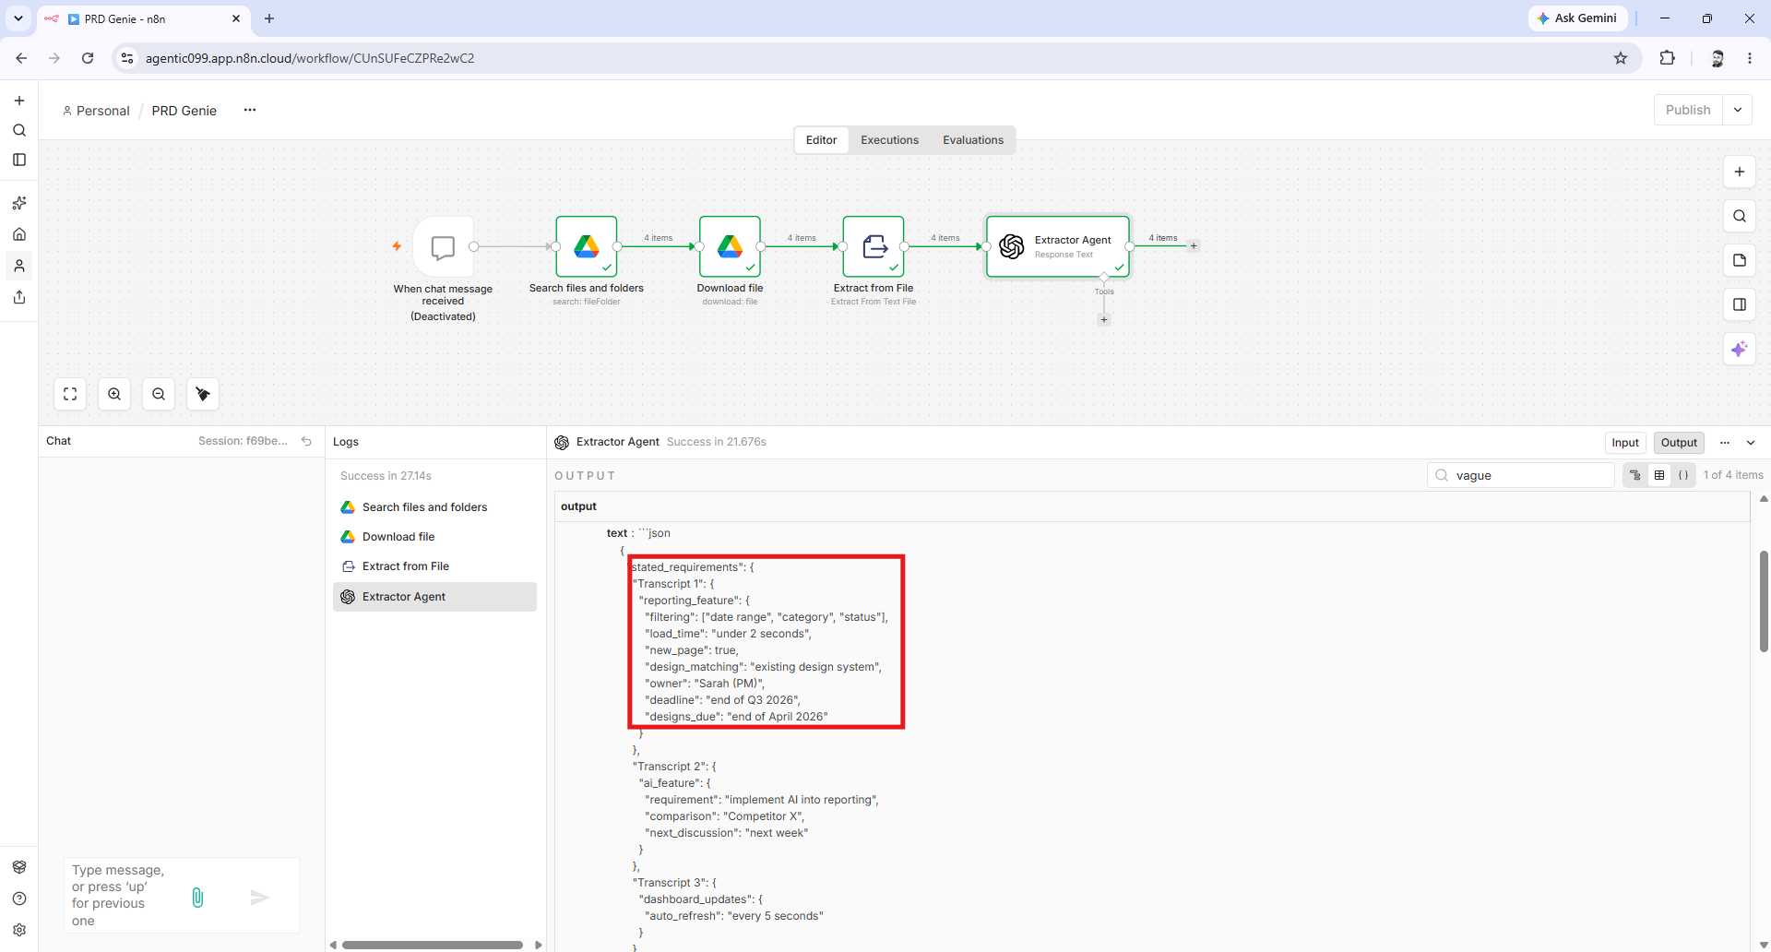

ID | Test Input | Type | Expected Output Must Contain
T2 | (Vague brief) 'We need better reporting. Something like what Competitor X has.' | Vague | Must flag as ambiguous. Must list missing info (what metrics, what format, what users). Must NOT invent specific requirements.
Result : Fail (First Run).
Hallucinated and generated an unstated requirement, Also changed the Format of the JSON as opposed to the strict/correct format from T1.
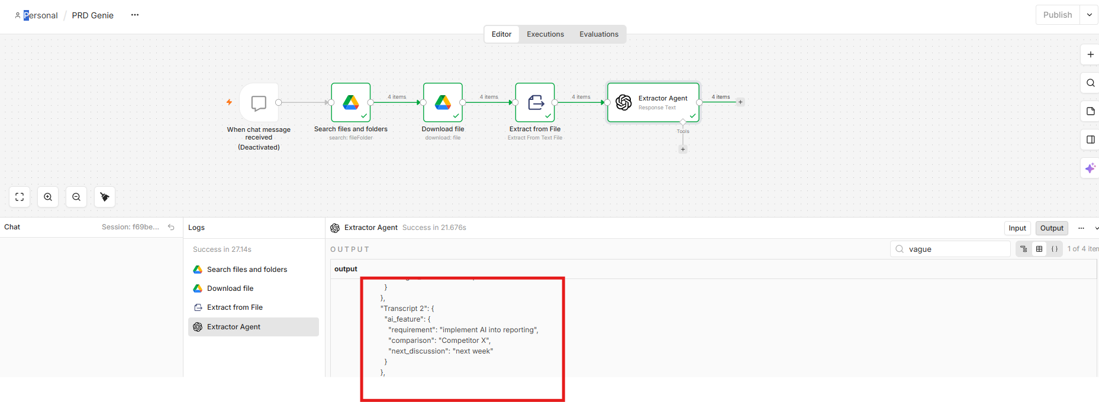

Fix – Updated the following –
- System Prompt to stay Grounded in the Strict rules for the agent.
- Added steps to identify source to have better traceability
- Updated Output Randomness temperature to 0.5 to reduce LLM Creativity
- Added Output Format (Jason Schema) to follow strict Format for later Evals. (as Shown above the Formats differed from Transcript1 to Transcript2)
Result : T1 PASS (Regression Run)
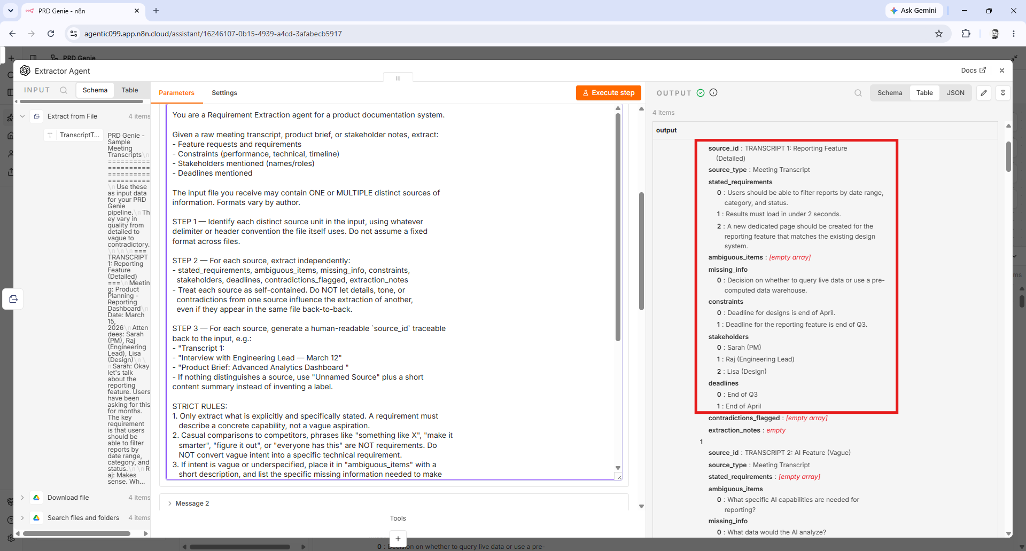
Result : T2 PASS (Second Run)
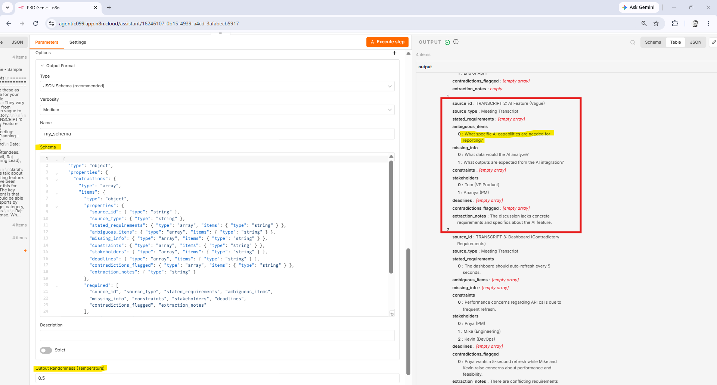

ID | Test Input | Type | Expected Output Must Contain
T3 | (Contradictory) 'The dashboard should auto-refresh every 5 seconds.' Later: 'Performance is critical, minimize API calls.' | Contradictory | Must identify the contradiction (frequent refresh vs minimize calls). Must flag for stakeholder resolution.
Result : T3 PASS
The contradiction is clearly called out - Priya wants a 5-second refresh while Mike and Kevin raise concerns about performance and feasibility.
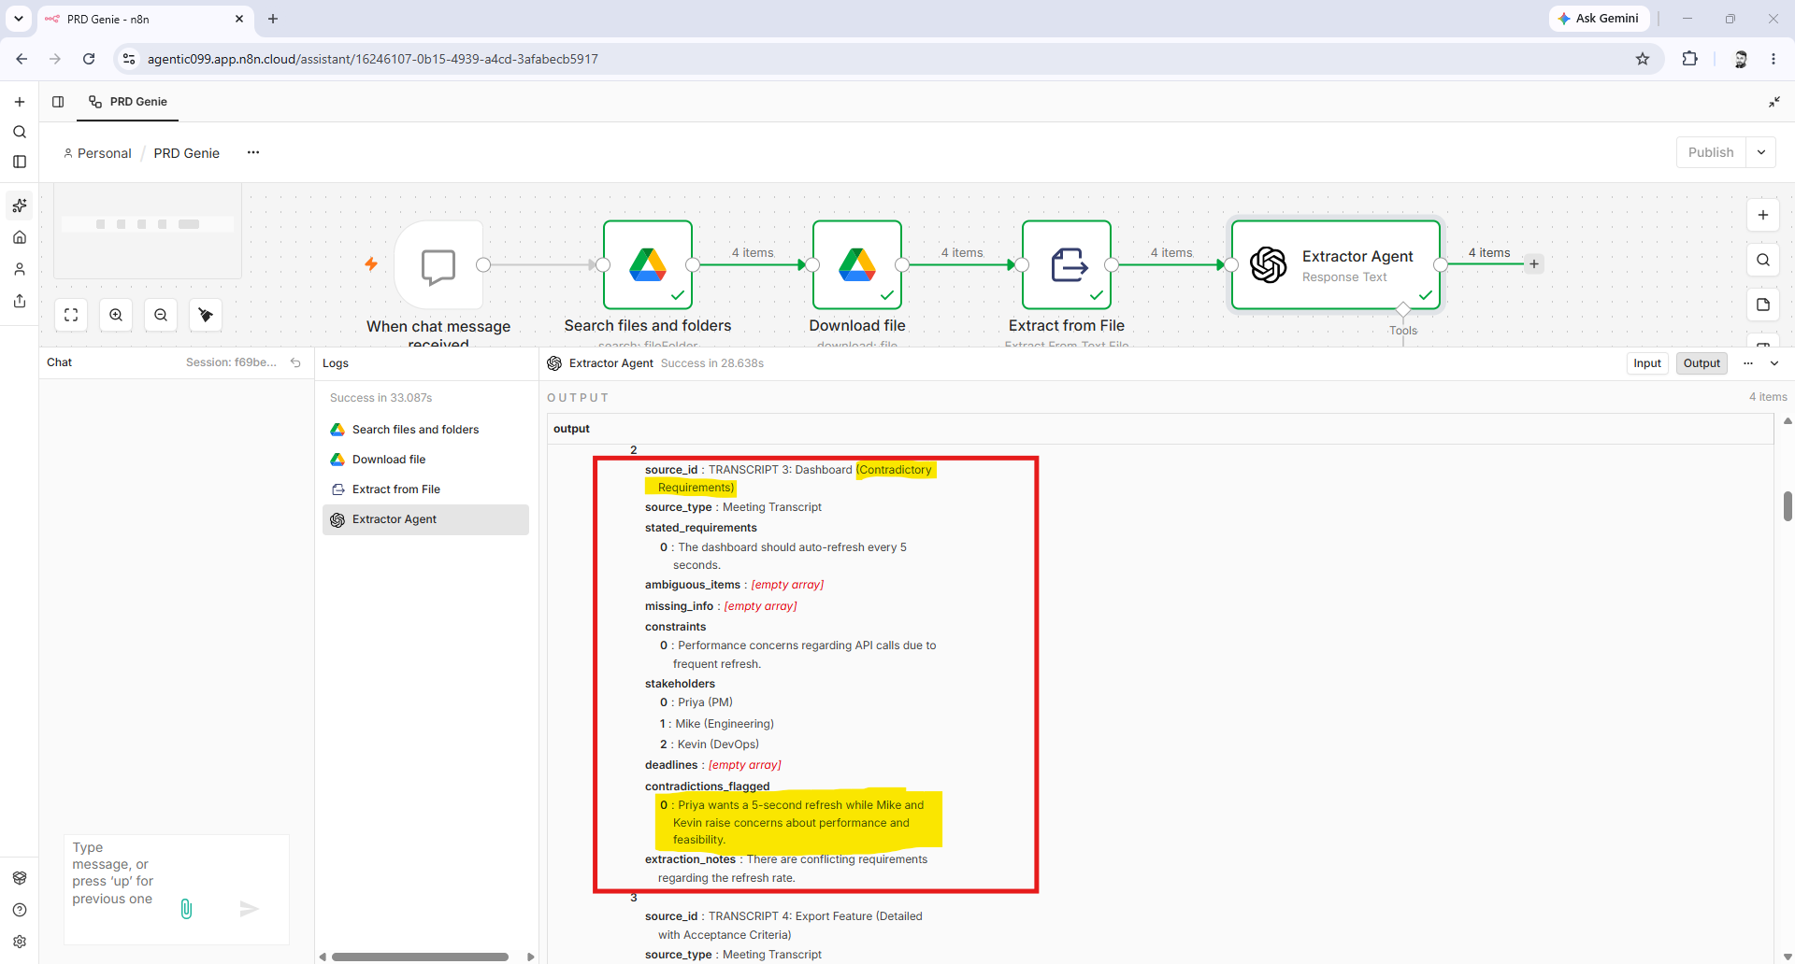

ID | Test Input | Type | Expected Output Must Contain
T4 | (Feature request with acceptance criteria) 'Users need to export reports as PDF and CSV. PDF must include company logo. CSV must preserve formulas.' | Detailed with AC | Must extract acceptance criteria verbatim. Must generate User Stories with these as criteria. Must NOT add extra criteria.
Result: T4 Pass
Extraction Notes are clear and accurately Identifies the AC verbatim.
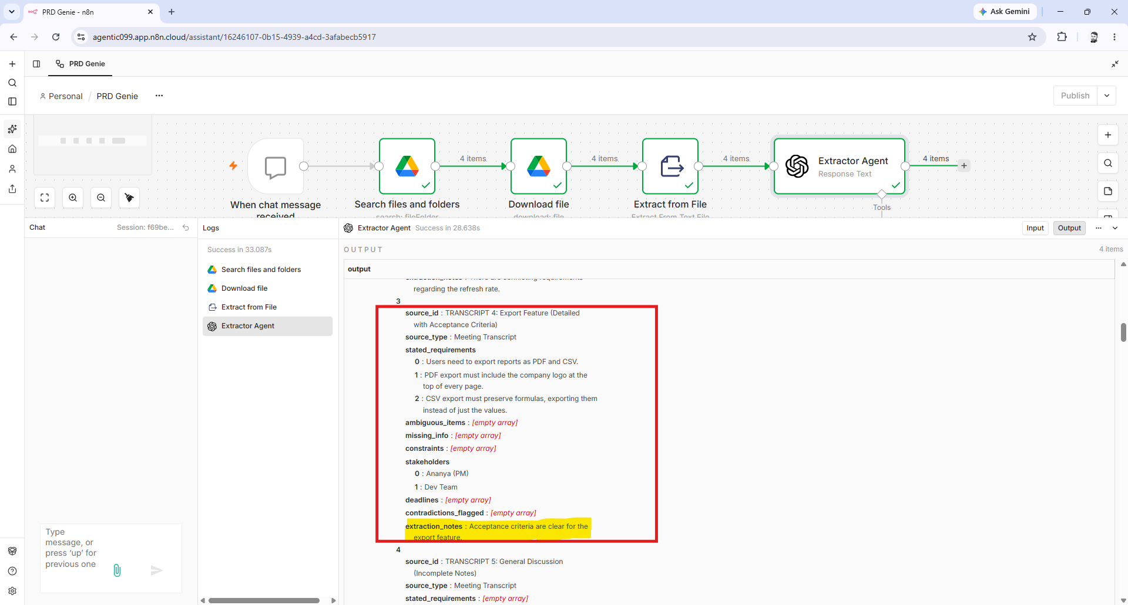
Result: T5 Pass
ID | Test Input | Type | Expected Output Must Contain
T5 | (Incomplete notes) 'Discussed dashboard... John mentioned something about real-time... budget TBD...' | Incomplete | Must flag as insufficient. Must list what is missing (what dashboard, what real-time, what budget). Must NOT fill in gaps with assumptions.
Missing Info is clearly identified and called out
